**Assignment -4**

|  |  |
| --- | --- |
| Assignment Date | 25 October 2022 |
| Student Name | Nitharshana.M |
| Team ID | PNT2022TMID48581 |
| Project Name | Project-Smart Farmer-IoT Enabled Smart Farming Application |
| Maximum Marks | 2 Marks |

**Question-1:**

**Write code and connections in wokwi for ultrasonic. Whenever distance is less than 100 cms send “alert” to ibm cloud and display in device recent events.**

**Solution:**

#define ECHO_PIN 2

#define TRIG_PIN 3

#define organization = "mmbh4c"

#define deviceType = "Ultrasonic"

#define deviceId = "pga460_sensor"

#define authMethod = "use-token-auth" #define authToken = "123456789"

void setup() { Serial.begin(9600); pinMode(TRIG_PIN, OUTPUT); pinMode(ECHO_PIN, INPUT);

}

float readDistanceCM() { digitalWrite(TRIG_PIN, LOW); delayMicroseconds(2); digitalWrite(TRIG_PIN, HIGH); delayMicroseconds(10); digitalWrite(TRIG_PIN, LOW); int duration = pulseIn(ECHO_PIN, HIGH); return duration * 0.034 / 2;

}

void loop() { float distance = readDistanceCM(); if(distance <=

100)

{

Serial.println("person detected ");

}

else{

Serial.print("Measured distance: ");

Serial.println(readDistanceCM());

}

delay(1000);

}

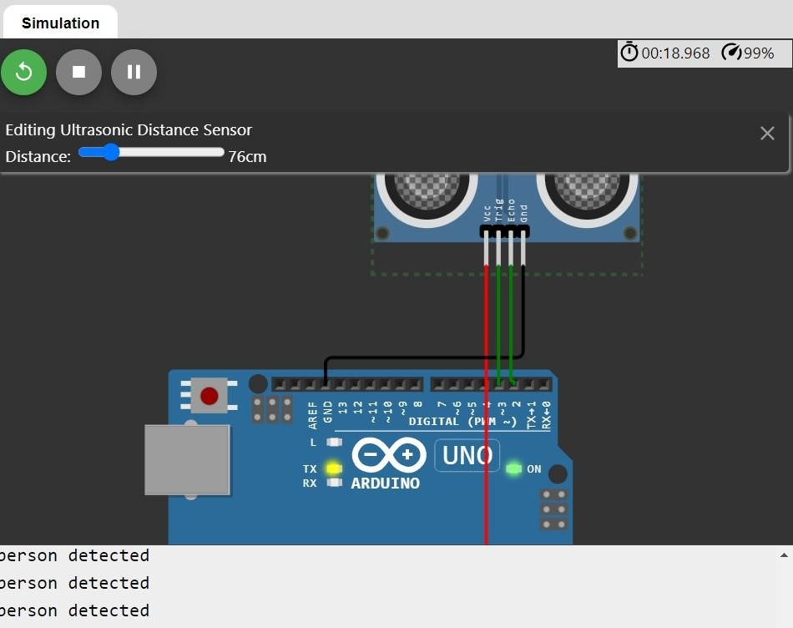

**Wokwi Link:** https://wokwi.com/projects/346094692918624851

# IBM Cloud

## Device Recent Events

